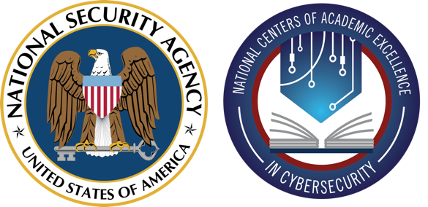

CAE Community of Practice in Cyber Defense (CoP-CD)
https://www.caecommunity.org/community-of-practice/cyber-defense

NCAE-C Student Code of Ethics and Professional Conduct Committee

Kelli Burgin
Montreat College
Anna Carlin
Fullerton College
Committee Members
Crystal | Dye | Southwest Virginia Community College
Doug | Jacobson | Iowa State University
Randall | Joyce | Murray State University
Dan | Manson | Norwich University
Valarie (Vickie) | McLain | Alexandria Technical and Community College
Ed | Skoudis | SANS Technology Institute
Gary | Sparks | Metropolitan Community College

NCAE-C Student Code of Ethics and Professional Conduct

As a cybersecurity student, you are expected to uphold a code of ethics and professional behavior that promotes the highest standards of integrity, honesty, trustworthiness, and professionalism. This code serves as a guide to help you make ethical decisions and maintain the trust and confidence of your clients, colleagues, and the public.
The following are the principles of the cybersecurity student code of ethics and professional behavior for students attending NCAE schools:
- Respect: Treat others with respect and honesty. Act in a legal and moral fashion regarding others. Respect the laws and regulations that govern your profession and do not engage in any activities that could be considered illegal or unethical.
- Professionalism: Conduct yourself in person and online in a professional manner, and always adhere to ethical standards when dealing with clients, colleagues, and the public. Your actions should be based on sound judgment, integrity, and the highest levels of ethical conduct.
- Confidentiality: Maintain the privacy and confidentiality of information, especially concerning protected health information, personally identifiable information, or intellectual property entrusted to you.
- Accountability: Take responsibility for your actions and be accountable for any mistakes or errors that you make. Learn from your mistakes and take steps to prevent them from happening again. Do no harm.
- Collaboration: Strive to collaborate online and in person with other cyber professionals to make the cyber world safer for all.
- Attribution: Give credit to others for their work. Only use work created by others and generative AI with proper attribution and explicit permission from your college, university, or employer.
- Continuous Learning: Continue as a life-long learner to ensure competency in the field. Share your knowledge with others and promote best practices.
- Reporting: Report any unethical behavior you observe in the course of your work to the appropriate authorities.

